SUMO Traffic Analysis Industry Report
Investigating Steeles Ave W-Keele St Traffic Conditions Using SUMO Simulation
Nicolas Jao, Jacob Kwan, Haonan Ouyang
McMaster University, Hamilton, Ontario, Canada

Abstract
Traffic simulation lets a municipality test changes to vehicle technology and signal control before it commits money to them. This industry report asks a hypothetical municipal question: what causes queues at the intersection of Steeles Avenue West and Keele Street, and does a proposed change improve conditions? Three aligned objectives answer the question. Objective 1 develops a digital road network and traffic model and characterizes the baseline with 100% human-driven vehicles (HDVs). Objective 2 compares the baseline with a 100% autonomous vehicle (AV) scenario. Objective 3 evaluates a signal timing change that raises the east-west green from 27 s to 41 s. Stage A1 builds the network in Simulation of Urban MObility (SUMO) from geographic information system (GIS) data. Stage A2 adds traffic demand, signal timing, and vehicle behavior. All three scenarios use the same selected edge, E78, and compare its speed-density relationship. The baseline fit has a coefficient of determination (R²) of 0.841, a free-flow speed of 6.72 m/s, and an implied capacity of about 816 veh/h. The AV scenario produces a near-identical relationship (R² = 0.836, capacity of about 822 veh/h), so the report finds no clear change. The intervention gives a mixed result: implied capacity rises 2.5% to about 837 veh/h, but R² falls to 0.744. The evidence supports further study, not implementation. Limitations include assumed demand and signal data, a single run, a single edge, and no field calibration.
Keywords: SUMO; traffic simulation; speed-density; autonomous vehicles; signal timing

1. Introduction

1.1. Background

A. Rationale for an integrated digital model
The study area is the intersection of Steeles Avenue West and Keele Street in the City of Vaughan, Ontario (43.7815378, -79.4945251). Steeles Avenue West is a major east-west arterial on the Vaughan-Toronto boundary, and Keele Street is a major north-south arterial. Finch Avenue West, Jane Street, Dufferin Street, and local streets feed both arterials. Figure 1 shows the study area on a GIS map.
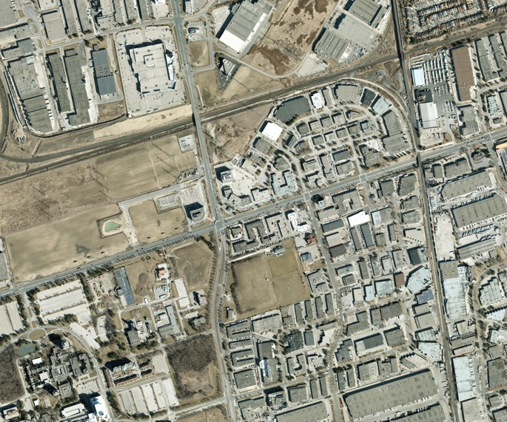

Figure 1. Study area GIS map of the Steeles Avenue West and Keele Street intersection
A digital roadway-and-traffic model lets us examine how the study intersection performs under controlled, repeatable conditions. The model also tests future traffic mixes of HDVs and AVs that cannot run on a live road. We build the model in SUMO, an open-source microscopic traffic simulator that moves each vehicle as an individual unit (Krajzewicz et al., 2012; Lopez et al., 2018). Stage A1 builds the road network and lanes. Stage A2 adds traffic lights and simulates HDV and AV traffic on that network. The order matters because signals and vehicle routes depend on the network, and a geometry error carries into every later result. Scenario comparisons carry meaning when the network is sound and the traffic sits on top of it. The intersection suits this test because it joins two major arterials at a municipal boundary and has several signalized movements, where a change in vehicle behavior stands out.

B. Case for controlled comparison in AV studies
A 100% AV scenario could change the speed-density relationship on an edge because vehicle behavior shapes that relationship, as the road does. An edge is a road segment in SUMO, and the speed-density relationship describes how vehicle speed falls as density, the number of vehicles per kilometre, rises. In simulation, AVs receive different car-following parameters than HDVs, such as shorter time headways, smaller reaction delays, and smoother acceleration and braking. A car-following model is the rule set that sets a vehicle's speed from the vehicle ahead. These differences could shift how speed falls as density rises, and so shift where congestion starts and how much flow the edge carries.
The direction of the shift is unknown. AVs could raise throughput and delay breakdown, the point where flow collapses into congestion (Shladover et al., 2012; Talebpour & Mahmassani, 2016). Conservative settings could lower speed or capacity, or the change could be too small to matter. These effects are hypotheses, not established improvements. The outcome could be an improvement, a deterioration, or no significant change. A controlled comparison with the 100% HDV baseline separates these outcomes. We hold the edge, network geometry, signal timing, and demand identical and change the vehicle type alone, so any difference in the speed-density curve traces to AV behavior and not to the setup. Without the baseline, a gain or loss that comes from the setup could pass as an AV effect.

C. Testing the intervention before investing
A municipality must make a defensible decision about a candidate engineering measure at the study intersection. Our group considers a major-road signal timing change. The change gives the north-south movements (Keele Street) 27 s of green and the east-west movements (Steeles Avenue West) 41 s of green. The split follows the modeled demand: the east-west through lanes carry 450 veh/h, and the north-south through lanes carry 300 veh/h. We choose signal timing because queue buildup and delay on the approaches are the typical issues at a busy signalized intersection of two major arterials, and signal timing controls how much green each movement receives (Federal Highway Administration [FHWA], 2008). Signal timing can improve flow without new construction and costs less than adding lanes, so it is a reasonable first measure for the City to evaluate.
The longer east-west green may shorten queues and raise speed on Steeles Avenue West. The same split reduces the share of the signal cycle that Keele Street receives, so queues on the north-south approaches could grow. The outcome could be an improvement, a deterioration, or no significant change. The simulation therefore tests the speed-density effect on the selected edge in place of an assumption. A comparison of the speed-density relationship on that edge before and after the timing change shows whether the measure raises speed at a given density, delays the start of congestion, or does nothing meaningful. The result gives the City evidence for a defensible decision.

1.2. Problem Statement

A. Problem 1: no digital baseline for the study intersection
Before the study evaluates AV or intervention scenarios, it needs a complete digital baseline. Stage A1 develops the roadway network for the study intersection, including major and local road geometry, lanes, turning lanes, and junction connections. Stage A2 adds traffic demand and signal timing at the selected intersection, documents the assumptions, runs the 100% HDV base scenario, and characterizes one representative major-road edge with its speed-density diagram. Together, Stage A1 and the Stage A2 baseline address Problem 1. This is a project requirement. It makes no claim that the City of Toronto lacks a digital model or traffic data.

B. Problem 2: untested AV effects on the selected edge
The City cannot infer 100% AV behavior on the selected edge from the HDV model alone. The study needs a 100% AV run with comparable demand, routing, network, signal, and simulation conditions, followed by a speed-density comparison on the same edge.

C. Problem 3: no before-and-after evidence for the intervention
The City considers investing in one transportation alternative, but nothing yet shows whether that intervention changes conditions on the selected edge. We select and justify a signal change based on the baseline diagnosis, implement it in Scenario 2, and compare speed-density observations on the same edge before and after the change. The exercise does not test every alternative or estimate monetary benefits.

1.3. Study Goal and Objectives
Study goal: The goal is to learn the causes of traffic in real-world conditions through simulation and to give a recommendation to the City of Toronto. To meet this goal, we develop and analyze an integrated digital roadway-and-traffic model of the existing Steeles Avenue West-Keele Street intersection across Stages A1 and A2. We then use the model to compare 100% AV conditions with the baseline and to evaluate our signal change intervention through speed-density evidence on the same selected major-road edge.
We use three objectives in this order. Each objective addresses the matching problem (A, B, or C) in Section 1.2.
- Objective 1: Develop a digital road network and traffic model for the existing study intersection and characterize the 100% HDV baseline.
- Objective 2: Compare and explain the selected edge's speed-density relationship in the 100% AV scenario versus the 100% HDV base scenario.
- Objective 3: Select, justify, implement, and evaluate the signal change intervention by comparing speed-density observations on that same edge before and after the change.

2. Literature Review
This section reviews the literature behind each objective.

A. Literature for Objective 1: network development and baseline behavior
Microscopic simulation represents each vehicle as a separate unit that moves under car-following and lane-changing rules. SUMO is an open-source microscopic simulator that builds road networks from map data and runs routed traffic demand over them (Krajzewicz et al., 2012; Lopez et al., 2018). Lopez et al. (2018) describe the SUMO workflow of network, demand, and output, and Eclipse SUMO (n.d.-a) documents how users define vehicles, vehicle types, and routes. This workflow matches the order of Stages A1 and A2: the network comes first, and demand and control follow.
Field traffic data are often incomplete. A transparent model states each assumption, such as demand, turning shares, and signal timing, so a reader can judge what the results support. We follow this practice and list our assumptions in Section 3.
The speed-density relationship summarizes how an edge behaves. Greenshields (1935) proposes a linear relationship in which speed falls from a free-flow speed at zero density to zero speed at jam density. Free-flow speed (vf) is the speed of a vehicle with no other vehicles nearby. Jam density (kj) is the density at which vehicles stop. Under the linear form, implied capacity, the maximum flow the edge carries, equals vf multiplied by kj and divided by four. We fit this form to the simulated observations and read vf, kj, and implied capacity as summary measures. SUMO writes aggregated edge speed and density through its edgeData output (Eclipse SUMO, n.d.-b), which supplies the observations for the fit.

B. Literature for Objective 2: HDV and AV modeling and comparison
Microscopic models give HDVs and AVs different behavior through parameters. The default car-following model in SUMO follows Krauss (1998), which sets vehicle speed so that a follower can always stop behind its leader without a collision. Parameters such as time headway (tau), minimum gap (minGap), speed deviation (sigma), acceleration, and deceleration then distinguish one vehicle type from another (Eclipse SUMO, n.d.-a). Time headway is the time gap between a vehicle and the one ahead, and speed deviation is the random variation in a driver's speed.
Studies of automated and cooperative vehicles link shorter headways to higher capacity. van Arem et al. (2006) simulate cooperative adaptive cruise control (CACC) and report better traffic-flow stability and higher throughput at high market penetration. Shladover et al. (2012) report that CACC raises freeway lane capacity as the CACC share grows. Talebpour and Mahmassani (2016) show that the effect of connected and autonomous vehicles on flow stability and throughput depends on the penetration rate and on the communication and control capability of the vehicles.
These studies address freeway flow, where signals do not interrupt traffic. The gap matters for a signalized arterial edge, where the signal phase can set speed more than car-following does. Section 4.B tests this point on edge E78.
A controlled comparison needs identical routes, traffic demand, geometry, controls, observation periods, and selected edge. If any of these differs between two runs, a difference in the speed-density curve has more than one possible cause. When the vehicle type alone changes, we attribute the difference to vehicle behavior.

C. Literature for Objective 3: simulation evidence for signal changes
Traffic simulation is a standard tool to test signal control changes before field use. Three studies illustrate the technique. El-Tantawy et al. (2013) develop a multiagent reinforcement learning controller, MARLIN-ATSC, for an integrated network of adaptive signals and test it in a simulation of downtown Toronto. They report lower delay than benchmark signal control. Wei et al. (2018) develop IntelliLight, a reinforcement learning approach to traffic light control, and test it in a simulator with real-world traffic data. They report better performance than baseline control methods. Liang et al. (2019) design a deep reinforcement learning network for traffic light cycle control, train it in SUMO, and report shorter vehicle waiting time.
The FHWA (2008) Traffic Signal Timing Manual supplies the engineering basis for our intervention, because it describes how cycle length and green splits allocate time among movements. The three studies above tune signals with learning algorithms, while our intervention is a simple fixed-time change in the green split. All four sources share one approach: they test a signal change in simulation before any field use. This approach supports our use of SUMO to test a 41 s east-west green.

3. Methodology
The methodology has three stages, one for each objective. Figure 2 shows the SUMO network for the 100% HDV scenario (panel a), the 100% AV scenario (panel b), and the intervention (panel c).
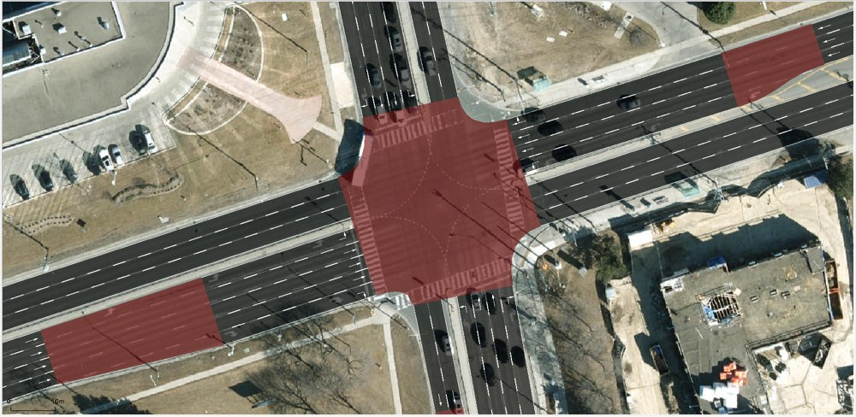  a) SUMO network: 100% HDV | b) SUMO network: 100% AV | 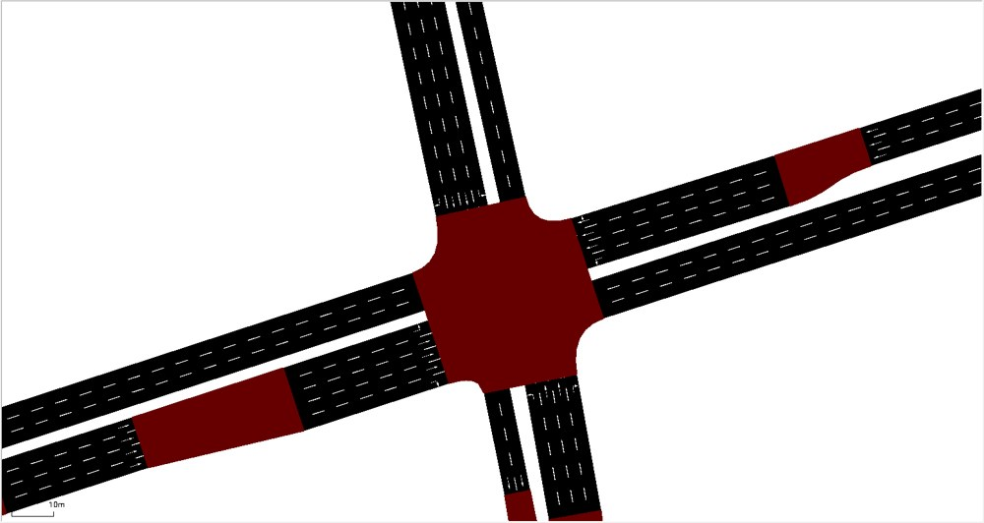  c) Intervention
Figure 2. Methodology: SUMO networks for the three scenarios

A. Method for Objective 1: network development and HDV baseline
We develop the methodology in two continuous stages. In Stage A1, we build the road network for the study intersection (43.7815378, -79.4945251) in SUMO. We define the GIS study boundary around the intersection and include the major roads (Steeles Avenue West and Keele Street) and the local roads that connect to them. We then model the junction geometry, the lane count on each approach and departure, the turning lanes, and the turning connections. Before we move on, we run network checks: the connectivity of all lane connections, the correct direction of each lane, and a visual inspection of the junction in SUMO. These checks make the geometry a fixed base for every later scenario.
Figure 3 shows two challenges in this stage. Challenge 1 (panel a) is the overlap of lane-to-lane connections inside the junction, where left, through, and right movements cross. Challenge 2 (panel b) is the match between the modeled connections and the lane markings and turn arrows in aerial imagery.
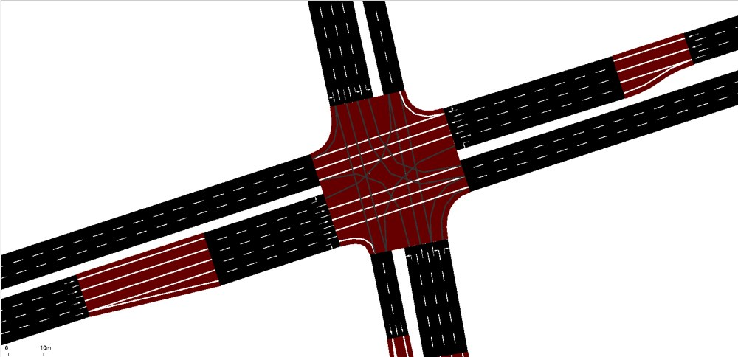  a) Challenge 1 | 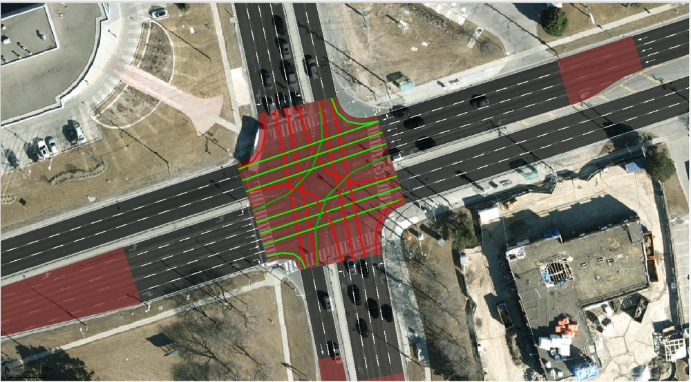  b) Challenge 2
Figure 3. Road network development challenges at the junction
In Stage A2, we configure the baseline on the validated network. We assign traffic demand and signal timing on the major roads, and Table 1 lists the baseline inputs. All vehicles are HDVs with base SUMO parameters, with two changes: the lane-change model is LC2013, and the cooperative parameter is 0.5. Each run aggregates edgeData at its end. We run the 100% HDV base scenario and use the edgeData output to produce the speed-density diagram for the selected edge. This diagram is the baseline for all later comparisons. The simulation duration and the observation period stay identical in every scenario.
Table 1. Baseline inputs for the 100% HDV scenario
Input | Value
East-west through demand (Steeles Avenue West) | 450 veh/h
North-south through demand (Keele Street) | 300 veh/h
Baseline green time, east-west | 27 s
Baseline green time, north-south | 27 s
Baseline cycle length | 60 s
Location of demand and signal timing | Major roads
Vehicle type | 100% HDV, SUMO default passenger car
Lane-change model | LC2013, cooperative = 0.5
Output | edgeData, aggregated at the end of the run

B. Method for Objective 2: controlled 100% AV simulation
Objective 2 isolates the effect of vehicle type on the same edge. We take the Stage A2 baseline and run a controlled 100% AV simulation (Scenario 1) on it. We hold the geometry, the selected edge, the traffic demand (450 veh/h east-west and 300 veh/h north-south), the routes, the turning shares, the baseline signal timing, the observation period, and the simulation duration unchanged. We replace the behavioral and composition variables that distinguish AVs from HDVs: the vehicle type changes from 100% HDV to 100% AV, with the AV parameters in Table 2.
Both vehicle types use the Krauss car-following model of SUMO, and the parameter values alone differ. The HDVs use the SUMO default values for a passenger car. The AVs keep shorter gaps, vary their speed less, and accelerate and brake harder than the HDVs. Because everything else is identical, any change in the results traces to AV behavior and not to the setup. We run Scenario 1 and extract the speed-density observations for the same edge from the edgeData output, with the same aggregation period as the baseline, so the AV and HDV relationships compare on equal terms. We treat the AV effect as a hypothesis. The result could be an improvement, a deterioration, or no significant change.
Table 2. Car-following parameters for HDVs and AVs in the Krauss model
Parameter | 100% HDV (SUMO default) | 100% AV
Time headway, tau (s) | 1.0 | 0.6
Minimum gap, minGap (m) | 2.5 | 1.5
Speed deviation, sigma | 0.5 | 0.05
Maximum acceleration (m/s²) | 2.6 | 2.9
Deceleration (m/s²) | 4.5 | 7.5
Emergency deceleration (m/s²) | 9.0 | 9.0

C. Method for Objective 3: justification and implementation of the signal change
Objective 3 tests one candidate measure against the issue diagnosed on the selected edge. In the base scenario, the eastbound and westbound lanes hold more waiting cars during red lights, and a small pile-up forms every cycle. The pile-up makes it hard for cars to turn left onto the northbound and southbound lanes. We choose a major-road signal timing change because the east-west through lanes carry 450 veh/h against 300 veh/h on the north-south through lanes, yet the baseline timing of 27 s for each direction does not serve the heavier movement in proportion to its demand. The modification sets the east-west (Steeles Avenue West) green to 41 s and keeps the north-south (Keele Street) green at 27 s, as Table 3 shows. We implement the change in Scenario 2 with 100% HDVs.
We expect speed on the selected edge to rise at a given density, and congestion to start at a higher density, because the longer green discharges the east-west queue each cycle. This is a hypothesis, not an established improvement. The north-south share of the cycle falls and may lengthen queues on Keele Street, so the result could be an improvement, a deterioration, or no significant change. We keep all unrelated inputs unchanged: the geometry, the selected edge, the demand, the routes, the turning shares, the vehicle behavior, the observation period, and the simulation duration. The east-west green is the sole difference from the base scenario. We run SUMO again and collect speed-density data from the same edge with the same edgeData aggregation, so the results compare on equal terms with the base scenario.
Table 3. Green times before and after the signal timing change
Movement | Base scenario (s) | Scenario 2 (s)
East-west green (Steeles Avenue West) | 27 | 41
North-south green (Keele Street) | 27 | 27

4. Result Analysis

A. Results for Objective 1: Stage A1 network and Stage A2 HDV baseline
Figure 4a shows the completed Stage A1 network for the study intersection (43.7815378, -79.4945251) in SUMO. The network reproduces the real road layout inside the GIS study boundary. Steeles Avenue West runs east-west, Keele Street runs north-south, and the two cross at the central signalized junction. The local roads that connect to these arterials stay in the network so that traffic enters and leaves the intersection in a realistic way and does not appear from nothing at the edge of the map.
Each road carries its own lane count and direction. At the junction, the through lanes, turning lanes, and turning connections link each approach lane to the correct departure lane, which lets vehicles make left, through, and right movements. We check that every approach connects, that no movement is blocked or missing, and that the junction matches the real intersection. Because this geometry stays fixed in every later scenario, any difference in the speed-density results links to the traffic and control changes we make, not to errors in the network.
Figure 4b shows the street we select as the upstream approach to the intersection, the northbound approach on Keele Street. Vehicles on an approach pass through the queue-forming zone before the signal, so the speed and density on this edge respond to how the intersection operates. That makes it a good edge for the speed-density diagram: when the signal holds traffic back, density rises and speed drops, and when green time grows, we see whether the edge recovers. A major-road approach also fits the study design, since demand and signal timing apply to the major roads. We use this one edge, E78, in the base scenario, the 100% AV scenario, and the intervention scenario, so every comparison uses the same edge. The baseline speed-density diagram for E78 appears in Figure 5a, and Table 4 lists its fitted parameters.
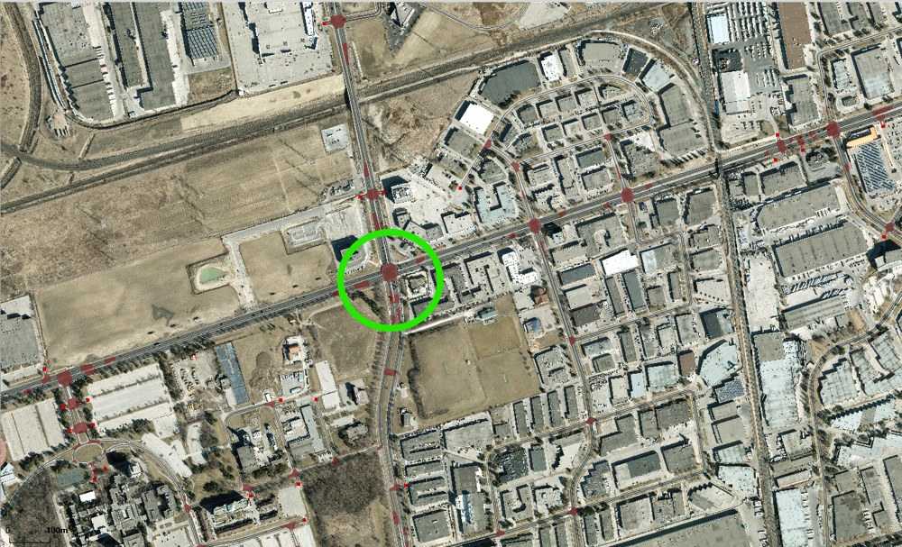  a) Developed SUMO network | 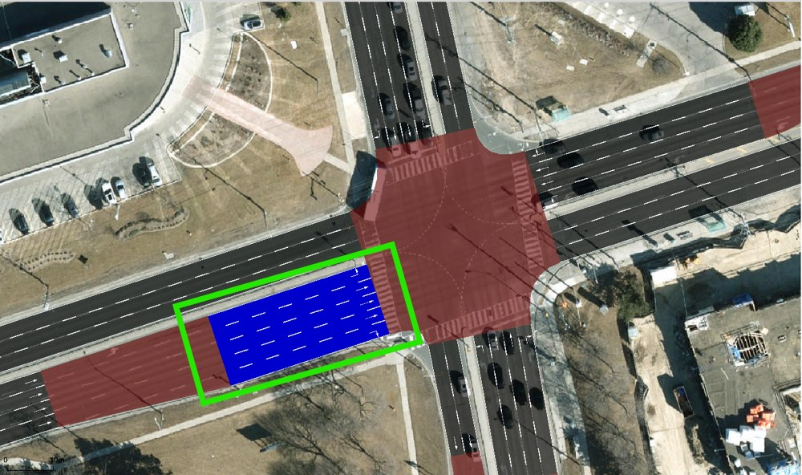  b) Selected street
Figure 4. Developed SUMO network and selected street for the speed-density analysis

B. Results for Objective 2: AV and HDV speed-density differences
Figure 5 shows the speed-density observations on edge E78 for the 100% HDV base scenario (panel a) and the 100% AV scenario (panel b). Table 4 compares the fitted parameters of the two scenarios.
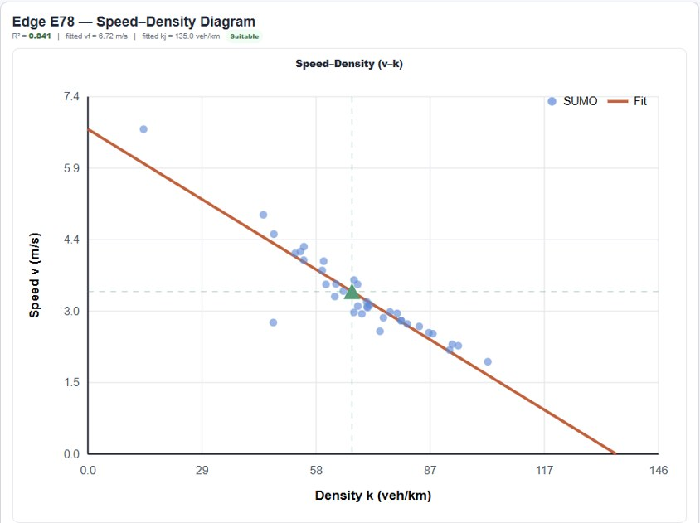  a) Base scenario (100% HDV) | 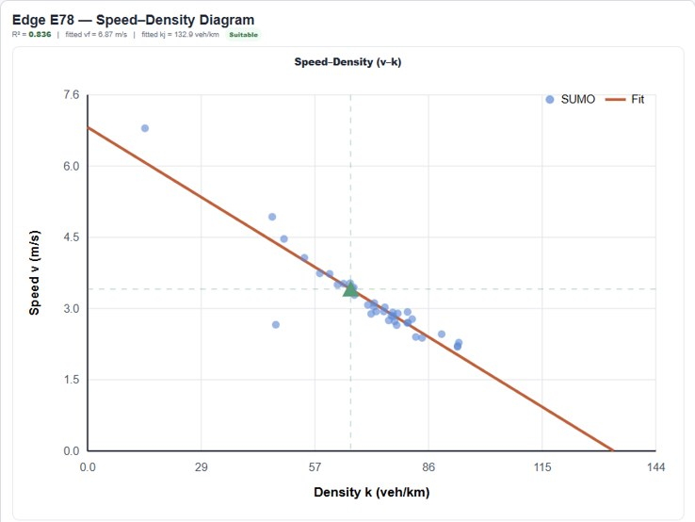  b) Scenario 1 (100% AV)
Figure 5. Speed-density observations on edge E78 for the 100% HDV and 100% AV scenarios
Table 4. Fitted speed-density parameters on edge E78 for the 100% HDV and 100% AV scenarios
Metric | 100% HDV base | 100% AV
R² | 0.841 | 0.836
Fitted free-flow speed (vf) | 6.72 m/s | 6.87 m/s
Fitted jam density (kj) | 135.0 veh/km | 132.9 veh/km
Implied capacity (vf × kj / 4) | ~816 veh/h | ~822 veh/h
Densest observations | ~103 veh/km at ~1.9 m/s | ~94 veh/km at ~2.2 m/s

Comparison and interpretation. On edge E78, the two scenarios produce a near-identical speed-density relationship. Both datasets show speed falling in a linear pattern as density rises, and the fits explain a similar share of the variation (R² of 0.841 and 0.836). In the range where the datasets overlap, from 45 to 95 veh/km, the speeds are close. At 70 veh/km both scenarios sit near 3 m/s, and at 80 to 90 veh/km both fall to 2.5 to 2.9 m/s. The fitted lines overlap: at 60 veh/km they predict 3.7 and 3.8 m/s, and at 94 veh/km both predict 2.0 m/s.
The parameter differences in Table 4 (vf of 6.72 and 6.87 m/s, kj of 135.0 and 132.9 veh/km, and capacity of about 816 and 822 veh/h) are 2% or less. They are too small to show that AVs hold higher or lower speeds than HDVs under comparable conditions. The defensible reading is no clear or significant change on this edge. The HDV run has a few points at 95 to 103 veh/km, and the AV run has none. This difference does not make the AV scenario better or worse, because it reflects the densities that each run reached.
Explanation of differences. The AV settings in Table 2 use a time headway of 0.6 s, a minimum gap of 1.5 m, a speed deviation of 0.05, and stronger acceleration and braking. In principle, a shorter tau and gap let vehicles queue with smaller spacing and discharge faster, and a lower sigma removes random speed variation. AVs could therefore show higher speed or a higher fitted capacity (Krauss, 1998; Shladover et al., 2012; Talebpour & Mahmassani, 2016). The results show a marginal shift in that direction.
The signal, not car-following behavior, controls this edge. Speeds stay below 7 m/s (about 25 km/h), so vehicles spend much of the time queuing and discharging at the signal. Both runs show the same outlier near 45 veh/km and 2.7 m/s, which suggests that the same signal cycle shapes the observations in both scenarios. When the signal phase, the upstream arrivals, and the downstream queue set the speed, tighter following behavior has little room to matter. The assigned demand of 450 veh/h east-west also sits below the fitted capacity of about 820 veh/h, so vehicles do not discharge at their limit, and the AV headway advantage may stay hidden. We expect the 0.6 s tau and 1.5 m gap to matter more in saturated flow or on an uninterrupted segment.
Limitations of the comparison. Four limitations apply to this result:
- Overlap and sample size. The densities overlap from 45 to 95 veh/km, and the HDV run reaches higher densities (to about 103 veh/km). Few observations exist at low density. Each run has one point near 14 veh/km, and the fitted vf depends on it, so the 0.15 m/s difference in vf is not reliable.
- Extrapolated jam density. Neither dataset comes close to 133 or 135 veh/km, so kj and the capacity derived from it are extrapolations, not observed values.
- Model form. A straight-line fit assumes a linear speed-density relationship. Signal-driven stop-and-go data may not follow a line, which limits what R² tells us.
- Single run and no validation. If each scenario is one run, differences this small could fall within run-to-run variation, and uncalibrated parameters limit the findings to simulated conditions.

C. Results for Objective 3: signal change before-and-after assessment
Diagnosed issue. In the 100% HDV base scenario, edge E78 shows speed falling as density rises (Figure 6a). Speeds stay below 7 m/s (about 25 km/h), and the densest observations, around 100 veh/km, crawl at under 2 m/s. This pattern points to queue buildup at the signal. The east-west through lanes also carry more demand (450 veh/h) than the north-south through lanes (300 veh/h).
Intervention rationale. We hypothesize that a longer green for the heavier east-west movement discharges queues faster and raises speed at a given density on edge E78. We implement the change in Scenario 2 with 100% HDVs and leave all other inputs unchanged. Figure 6 shows the speed-density observations for both scenarios, and Table 5 compares the fitted parameters.
a) Base scenario (100% HDV) | 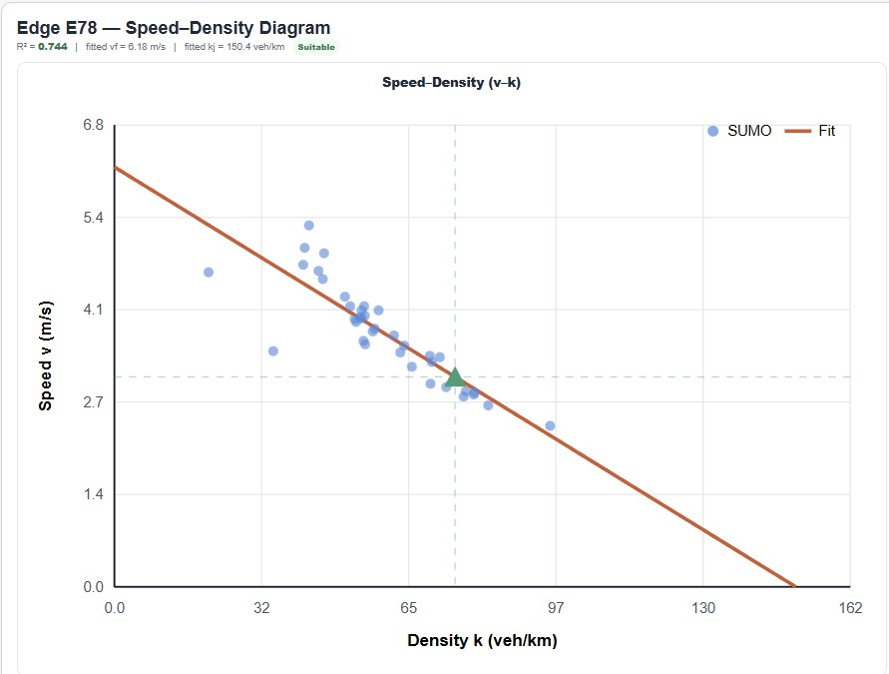  b) Scenario 2 (intervention)
Figure 6. Speed-density observations on edge E78 before and after the signal timing change
Table 5. Fitted speed-density parameters on edge E78 before and after the signal timing change
Metric | Base | Scenario 2
R² | 0.841 | 0.744
Fitted free-flow speed (vf) | 6.72 m/s | 6.18 m/s
Fitted jam density (kj) | 135.0 veh/km | 150.4 veh/km
Implied capacity (vf × kj / 4) | ~816 veh/h | ~837 veh/h
Densest observations | ~103 veh/km at ~1.9 m/s | ~95 veh/km at ~2.3 m/s

Presence of the hypothesized effect. The effect is weak. As Figure 6 shows, the two fitted lines overlap in the overlapping range of 42 to 95 veh/km. At 60 veh/km both predict 3.7 m/s. At 90 veh/km the intervention line sits higher, at about 2.5 m/s against 2.2 m/s. The densest Scenario 2 observations are also less severe, at about 2.3 m/s against 1.9 m/s, but they occur at a lower density than the base observations, so the two sets do not compare like for like.
Support for further investigation. The evidence supports further study, with a small margin. Table 5 shows a small hint of improvement at high density and a capacity gain of about 2.5%, from about 816 to about 837 veh/h. The intervention data also fit the linear relationship less well, with R² falling from 0.841 to 0.744. The scatter grows between 40 and 55 veh/km, where speeds range from 3.5 to 5.3 m/s. The lower vf (6.72 to 6.18 m/s) is a sampling artifact, because a single point near 14 veh/km pulls the base fit upward. The evidence justifies further study, not a recommendation to implement.
Remaining uncertainty. Neither dataset approaches kj, so the kj values and the capacity gain that depends on them are extrapolations. The results come from a single run, as far as we know, so the differences may fall within run-to-run variation. We analyze one edge, so any added waiting on the north-south approach (Keele Street) goes unmeasured. We hold no cost or alternatives evidence, so we draw no conclusion about cost-effectiveness or optimality.

5. Conclusion and Recommendation

5.1. Conclusion

A. Conclusion for Objective 1: what Stages A1 and A2 establish
The first objective is to develop a digital roadway and traffic model of the study intersection. Stage A1 produces a road network that represents the intersection geometry, the major and local roads, the lane configurations, the turning movements, and the junction connections.
Stage A2 adds traffic demand, signal timing, and HDV behavior to establish the 100% HDV baseline. The east-west through lanes carry 450 veh/h, and the north-south through lanes carry 300 veh/h. On the selected edge, E78, the baseline speed-density relationship fits well (R² = 0.841), with a free-flow speed of about 6.72 m/s, a jam density of about 135 veh/km, and an implied capacity of about 816 veh/h. The densest observations, around 100 veh/km, show speed below 2 m/s, which indicates queue buildup on this edge.
The model has limitations. Traffic volumes and signal timing rest on project assumptions, not field measurements, and we have not calibrated the model with real traffic data. The baseline serves as a reference for comparing scenarios and may not represent actual conditions.

B. Conclusion for Objective 2: what the controlled AV comparison shows
The second objective is to compare the speed-density relationship of 100% HDVs and 100% AVs on the same selected edge. With the network, demand, routes, turning shares, and signal timing unchanged, the vehicle behavior parameters are the sole difference. The AV settings use a shorter time headway (0.6 s), a smaller minimum gap (1.5 m), a lower speed deviation (0.05), and stronger acceleration and braking.
The comparison shows no clear or significant change. The fitted parameters differ by 2% or less, and the fitted lines overlap in the shared density range. The signal sets speed on this edge and leaves little room for the shorter AV headway to matter. The result depends on the chosen vehicle settings and on the overlap between the HDV and AV density ranges. Because we have not validated the model against real traffic data, the findings do not prove how AVs perform in real traffic.

C. Conclusion for Objective 3: whether the signal change warrants further consideration
The third objective is to evaluate whether a change in signal timing improves conditions on the selected edge. The intervention gives Steeles Avenue West 41 s of green and Keele Street 27 s, which favors the east-west movements that carry the higher demand (450 against 300 veh/h). Scenario 2 uses 100% HDVs and keeps the network, demand, routes, and vehicle behavior unchanged.
The speed-density results show a marginal and mixed change. In favor of the intervention, the fitted capacity rises about 2.5%, from about 816 to about 837 veh/h, and the fitted jam density increases from 135.0 to 150.4 veh/km. The most congested observations are also less severe, with speed down to about 2.3 m/s against about 1.9 m/s in the base run.
Several results do not support the intervention. The goodness of fit drops from R² = 0.841 to 0.744, with more scatter at 40 to 55 veh/km, where speeds range from 3.5 to 5.3 m/s. The fitted free-flow speed falls from 6.72 to 6.18 m/s, although part of this change is a sampling artifact of the single low-density point in the baseline fit. The jam density is an extrapolation in both scenarios, so the capacity gain that depends on it is not reliable.
The evidence suggests a modest improvement at most, and it does not show that the change works. A longer green for one direction also risks longer waits on Keele Street, which this single-edge analysis does not capture. The intervention warrants further consideration after additional analysis.

5.2. Recommendation

A. Recommendation to the City of Toronto
We recommend that the City of Toronto not implement the 41 s east-west green on the strength of this study alone. The simulation shows a small hint of improvement at high density, but the evidence is too weak to justify a change at the study intersection. We recommend that the City commission further analysis before it decides. That analysis includes results for both the east-west and north-south approaches, delay metrics, a safety evaluation, and field data on traffic volumes and signal timing. The AV comparison adds a separate point: at this demand, AV car-following settings do not change the speed-density relationship on a signal-controlled edge in a way that this model detects.

B. Study limitations and next steps
Four limitations frame the next steps for the integrated Stage A1 and Stage A2 model.
- Network simplification. We develop the Stage A1 road network from GIS information, and it includes some simplifications. Future studies should verify road geometry, lane numbers, turning movements, and junction connections with detailed field observations.
- Assumed demand and signal data. Stage A2 uses assumed traffic demand and signal timing and omits additional demand or signal control on local roads. Future work should collect actual traffic volumes, turning counts, and signal timing data at Steeles Avenue West and Keele Street so that the model can be calibrated and validated against real conditions.
- Simplified vehicle behavior. The HDV and AV scenarios use simplified behavior parameters. Future studies should test different following times, minimum gaps, and acceleration settings, and should examine mixed traffic with different shares of HDVs and AVs.
- Single run and single edge. The intervention results come from one selected edge and, as far as we know, one simulation run, so the differences in R² and the fitted parameters could fall within normal run-to-run variation. Future work should run several random seeds per scenario, report average travel time, waiting time, and queue length from SUMO, and evaluate both the east-west and north-south approaches to measure the net effect on the whole intersection.

References
Eclipse SUMO. (n.d.-a). Definition of vehicles, vehicle types, and routes. https://sumo.dlr.de/docs/Definition_of_Vehicles%2C_Vehicle_Types%2C_and_Routes.html
Eclipse SUMO. (n.d.-b). Lane- or edge-based traffic measures. https://sumo.dlr.de/docs/Simulation/Output/Lane-_or_Edge-based_Traffic_Measures.html
El-Tantawy, S., Abdulhai, B., & Abdelgawad, H. (2013). Multiagent reinforcement learning for integrated network of adaptive traffic signal controllers (MARLIN-ATSC): Methodology and large-scale application on downtown Toronto. IEEE Transactions on Intelligent Transportation Systems, 14(3), 1140–1150. https://doi.org/10.1109/TITS.2013.2255286
Federal Highway Administration. (2008). Traffic signal timing manual (Report No. FHWA-HOP-08-024). U.S. Department of Transportation. https://rosap.ntl.bts.gov/view/dot/800
Greenshields, B. D. (1935). A study of traffic capacity. Highway Research Board Proceedings, 14, 448–477.
Krajzewicz, D., Erdmann, J., Behrisch, M., & Bieker, L. (2012). Recent development and applications of SUMO: Simulation of Urban MObility. International Journal on Advances in Systems and Measurements, 5(3–4), 128–138. https://elib.dlr.de/80483/
Krauss, S. (1998). Microscopic modeling of traffic flow: Investigation of collision free vehicle dynamics [Doctoral dissertation, University of Cologne].
Liang, X., Du, X., Wang, G., & Han, Z. (2019). A deep reinforcement learning network for traffic light cycle control. IEEE Transactions on Vehicular Technology, 68(2), 1243–1253. https://doi.org/10.1109/TVT.2018.2890726
Lopez, P. A., Behrisch, M., Bieker-Walz, L., Erdmann, J., Flötteröd, Y.-P., Hilbrich, R., Lücken, L., Rummel, J., Wagner, P., & Wießner, E. (2018). Microscopic traffic simulation using SUMO. In 2018 21st International Conference on Intelligent Transportation Systems (ITSC) (pp. 2575–2582). IEEE. https://doi.org/10.1109/ITSC.2018.8569938
Shladover, S. E., Su, D., & Lu, X.-Y. (2012). Impacts of cooperative adaptive cruise control on freeway traffic flow. Transportation Research Record, 2324, 63–70.
Talebpour, A., & Mahmassani, H. S. (2016). Influence of connected and autonomous vehicles on traffic flow stability and throughput. Transportation Research Part C: Emerging Technologies, 71, 143–163. https://doi.org/10.1016/j.trc.2016.07.007
van Arem, B., van Driel, C. J. G., & Visser, R. (2006). The impact of cooperative adaptive cruise control on traffic-flow characteristics. IEEE Transactions on Intelligent Transportation Systems, 7(4), 429–436. https://doi.org/10.1109/TITS.2006.884615
Wei, H., Zheng, G., Yao, H., & Li, Z. (2018). IntelliLight: A reinforcement learning approach for intelligent traffic light control. In Proceedings of the 24th ACM SIGKDD International Conference on Knowledge Discovery & Data Mining (pp. 2496–2505). Association for Computing Machinery. https://doi.org/10.1145/3219819.3220096

